- Logged-in User_ Header is breaking.
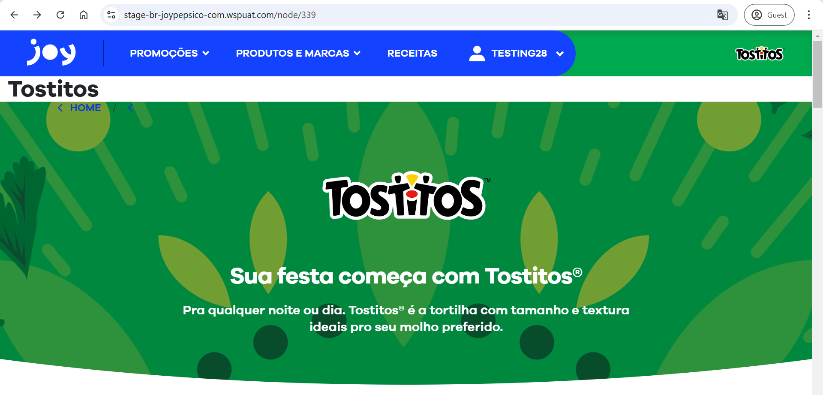
- Logged-in User_ URL should be updated.
- If we are selecting & Deselecting the “Compare” from Product Details Popup then the highlight is not getting removed until we click outside.
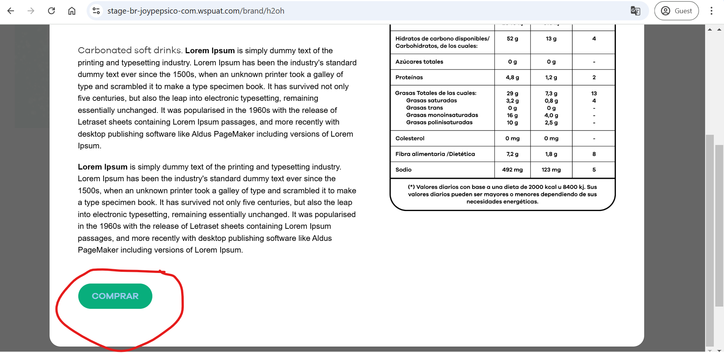
- If we are selecting the “Compare” button in product details popup then the external site logos are not consistent, and the page scroll is also not working.
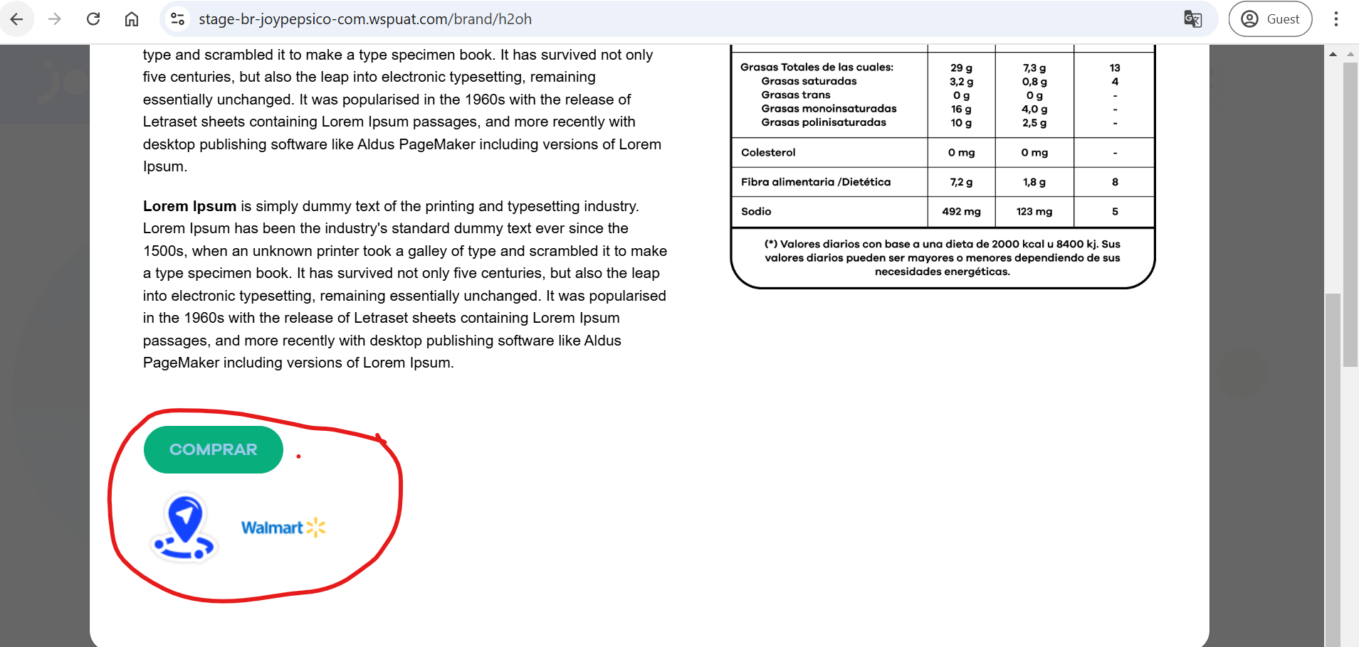
- Product scroll arrow icons are not in white color.
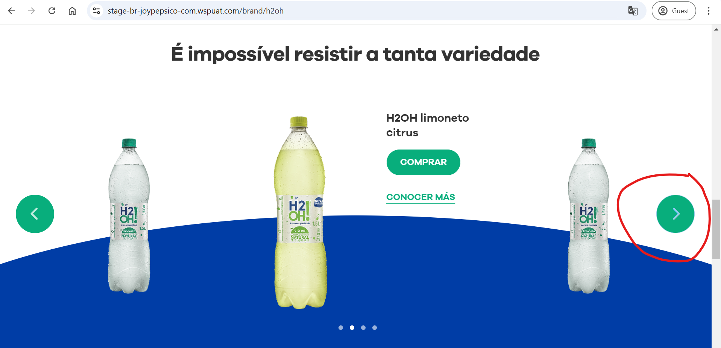
- Compare & Know More buttons are not parallelly aligned.
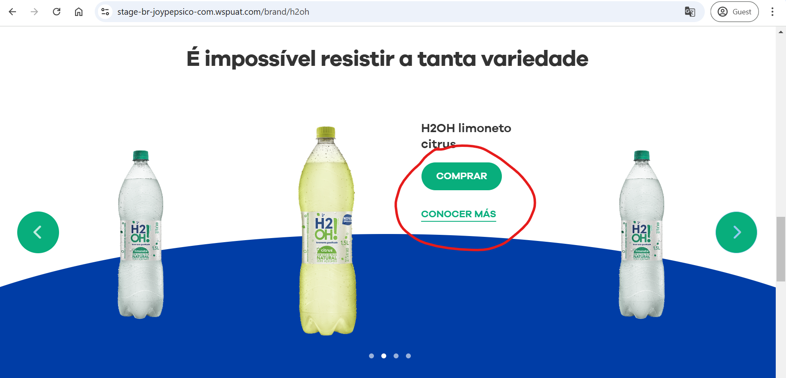
- For Lipton_ Product scroll arrow is in Yellow but after selecting color is not changing.
